

Windows Workflow Foundation

Hands-On Lab

Lab Manual
Lab 10 – Embedding the Workflow Designer in C#

Information in this document, including URL and other Internet Web site references, is subject to change without notice. This document supports a preliminary release of software that may be changed substantially prior to final commercial release, and is the proprietary information of Microsoft Corporation.

This document is for informational purposes only. MICROSOFT MAKES NO WARRANTIES, EITHER EXPRESS OR IMPLIED, AS TO THE INFORMATION IN THIS DOCUMENT.

The entire risk of the use or the results from the use of this document remains with the user. Complying with all applicable copyright laws is the responsibility of the user. Without limiting the rights under copyright, no part of this document may be reproduced, stored in or introduced into a retrieval system, or transmitted in any form or by any means (electronic, mechanical, photocopying, recording, or otherwise), or for any purpose, without the express written permission of Microsoft Corporation.

Microsoft may have patents, patent applications, trademarks, copyrights, or other intellectual property rights covering subject matter in this document. Except as expressly provided in any written license agreement from Microsoft, the furnishing of this document does not give you any license to these patents, trademarks, copyrights, or other intellectual property.

Unless otherwise noted, the example companies, organizations, products, domain names, e-mail addresses, logos, people, places and events depicted herein are fictitious, and no association with any real company, organization, product, domain name, email address, logo, person, place or event is intended or should be inferred.

© 2005 Microsoft Corporation. All rights reserved.

Microsoft, MS-DOS, Windows, Windows NT, Windows Server, Visual C# and Visual Studio are either registered trademarks or trademarks of Microsoft Corporation in the United States and/or other countries.

The names of actual companies and products mentioned herein may be the trademarks of their respective owners.

Contents
Lab 12: Embedding the Workflow Designer 1
Lab Objective 1
Exercise 1 – Displaying a Workflow in a Windows Forms Application 1
Task 1 – Creating a new Windows Forms Project 1
Exercise 2 – Interacting Programmatically with the Workflow Designer in a Windows Forms Application 8
Task 1 – Implement Zoom Functionality to the WorkflowDesignerControl 8
Task 2 – Design the Zoom functionality Interface 8
Exercise 3 – Adding Activities to the Workflow Designer in a Windows Forms Application 12
Task 1 – Add an Activity ToolBox to the Workflow Designer 12
Task 2 – Enabling the User to Select an Activity in the Workflow Designer 14
Task 3 – Enabling the User to Delete an Activity in the Workflow Designer 17
Exercise 4 – Programmatically Opening, Saving, Compiling and Running Workflows in the Workflow Designer 20
Task 1 – Design the User Interface 20
Task 2 – Add Common File Operations 21
Task 3 – Bind Activities In the Workflow Designer 28
Lab Summary 33

Lab 12: Embedding the Workflow Designer
Estimated time to complete this lab: 50 minutes
The project files for this lab are in the C:\Windows Workflow Foundation\Labs\Lab10 folder.

Lab Objective
Windows Workflow Foundation provides workflow designer controls for building custom workflow, activity, and rule designers. These are provided so that independent software developers can make better use of Windows Workflow Foundation in line of business applications. The objective of this lab is to demonstrate how to build a simple Windows Forms workflow designer using the workflow designer control. After completing this lab, you will be able to:
- Display a Workflow in a Windows Forms application
- Interact programmatically with the workflow designer control in a Windows Forms application
- Programmatically add activities to the workflow designer control in a Windows Forms application
- Programmatically open, save, compile and run workflows

This lab has a lot of code which needs to be added to the projects. The soft copy of this lab document is available to you on the lab machine. It is recommended that you use the provided code snippets as you work through the lab.

Exercise 1 – Displaying a Workflow in a Windows Forms Application

In this exercise, you will create a Windows Forms application that will be comprised of a ToolStrip containing simple Windows controls such as Buttons and a Workflow design surface, which will initially display an empty workflow.

Task 1 – Creating a new Windows Forms Project

- Open Microsoft Visual Studio 2005, click Start | Programs | Microsoft Visual Studio 2005 | Microsoft Visual Studio 2005.
- In Visual Studio 2005, click File | New | Project.
- In the New Project dialog box, in the Project types tree on the left expand Visual C# | Windows.
- Select the Windows Application template and enter the following values for the Name and Location:
Name: DesignerHostingApplication
Location: C:\Windows Workflow Foundation\Labs\Lab10
- Before we begin creating our designer host application we must add two projects to our solution.
  - WorkflowDesignerControl: This project contains our workflow display control
  - ActivityLibrary: This project contains two custom Workflow activities which we will use throughout the lab.
- Copy the following two project directories, WorkflowDesignerControl and ActivityLibrary from the C:\Windows Workflow Foundation\Labs\Lab10\Resources to C:\Windows Workflow Foundation\Labs\Lab10\DesignerHostingApplication.

Your working directory should now look similar to this:

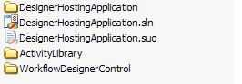

- To add the projects to our solution, right-click the Solution file in the Solution Explorer and click Add Existing Project.
- In the Open File Dialog, navigate to C:\Windows Workflow Foundation\Labs\Lab10\ DesignerHostingApplication\WorkflowDesignerControl and select the WorkflowDesignerControl.csproj file.
- Right-click the solution file a second time and select Add Existing Project.
- In the Open File Dialog, navigate to C:\Windows Workflow Foundation\Labs\Lab10\ DesignerHostingApplication\ ActivityLibrary and select the ActivityLibrary.csproj file.

Your solution should now look similar to this

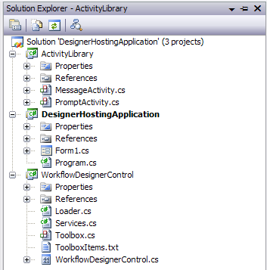

- In the Solution Explorer, right-click the WorkflowDesignerControl project and select Add Reference.
- In the Add Reference window, select the Projects tab and select ActivityLibrary.

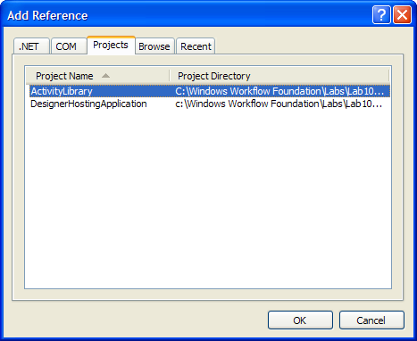

- Click OK.
- In the Solution Explorer, right-click the DesignerHostingApplication project and select Add Reference.
- In the Add Reference window, click the Projects tab and select ActivityLibrary and WorkflowDesignerControl.

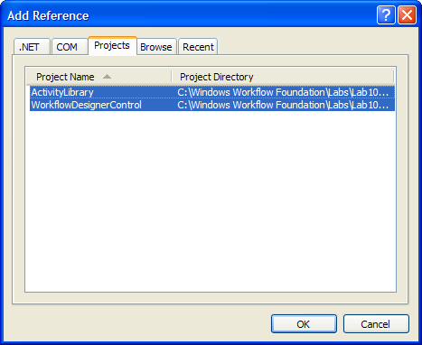

- Click OK.
- In the Solution Explorer, right-click the DesignerHostingApplication project and select Add Reference.
- In the Add Reference window, click the .Net tab and select the following components:
- System.Design
- System.Drawing.Design
- System.Workflow.Activities
- System.Workflow.ComponentModel
- In the File menu select Save All or press CTRL + SHIFT + S,
- In the Build menu select Build Solution or press F6, ensure all three projects build with no errors.

Task 2 – Defining the User Interface for the Windows Application

- In Solution Explorer, right-click Form1.cs, and click Rename. Rename Form1.cs to DesignerShell.cs. Accept the dialog to rename all references.
- In Solution Explorer, right-click DesignerShell.cs, and click View Designer.
- Click the form in the designer and press F4 to open the Properties window. Set the Text property of the form to DesignerShell.
- Set the Size property to Width: 600 and Height: 500.
- Open the Toolbox if it is not already open, and expand the All Windows Forms node in the Toolbox.
- Drag and drop a Toolstrip onto the design surface of the form and set the properties as follows:
  - Name: toolStrip
  - GripStyle: Hidden
  - RenderMode: System
  - Ensure the Dock property is set to Top

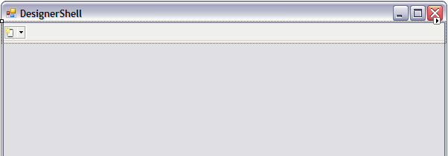

- Return to the Toolbox and expand the WorkflowDesignerControl Components node.
- You should see a WorkflowDesignControl which has been built from our WorflowDesignControlProject. Drag and drop a WorkflowDesignControl onto the design surface of the form just under the toolStrip.

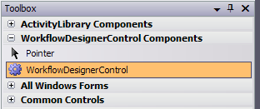

- Set the properties of the control as follows:
  - Name: workflowDesignerControl
  - Dock: Fill
- Your form should look similar to this:

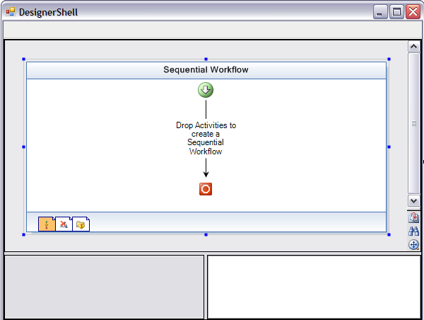

- Press F6 to build the solution, verify that all the projects build successfully

Exercise 2 – Interacting Programmatically with the Workflow Designer in a Windows Forms Application

In this exercise, you will write code that responds to events and that can manipulate activities in the embedded Workflow Designer. You will also write code that enables the user to zoom in the Workflow Designer.

Task 1 – Implement Zoom Functionality to the WorkflowDesignerControl

- In the Solution Explorer, right-click on WorkflowDesignerControl.cs and select View Code.
- Insert the following method at the end of WorkflowDesignerControl class just after the LoadWorkFlow method, to support zooming:

(Snippet: Lab10_Ex02_Task01_ProcessZoom)
public void ProcessZoom(int zoomFactor)
{
this.workflowView.Zoom = zoomFactor;
this.workflowView.Update();
}

- Rebuild the solution by pressing F6.

Task 2 – Design the Zoom functionality Interface
In this task we will build the user interface to allow the user to zoom the workflow designer in and out using three predefined zoom levels 25%, 100% and 200%.

- In the Solution Explorer, right-click on DesignerShell.cs and select View Code.
- Insert the following method to invoke the zoom functionality in the DesignerShell class just below the constructor.

(Snippet: Lab10_Ex02_Task02_ZoomMenuItem_Click)
private void zoomDropDownMenuItem_Click(object sender, EventArgs e)
{
if (sender is ToolStripMenuItem)
{
ToolStripMenuItem menuItem = (ToolStripMenuItem)sender;

int zoomFactor = 0;

bool result = Int32.TryParse(menuItem.Tag.ToString(), out zoomFactor);

if (result)
{
this.workflowDesignerControl.ProcessZoom(zoomFactor);
}
}
}

- In the Solution Explorer, right-click on DesignerShell.cs and select View Designer.
- Select the toolStrip control at the top of the form.
- Using the SmartTasks tool, add a DropDownButton to the toolStrip.

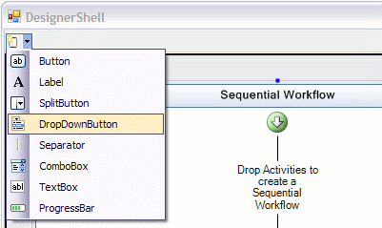

- The new DropDownButton will be created, select it and set it’s properties as follows:
- Name: zoomDropDown
- DisplayStyle: Text
- Text: Zoom
- Click the zoomDropDown Button and using the designer add three items to the drop down.
  - Item01
    - Text: 25%
  - Item02
    - Text: 100%
  - Item03
    - Text: 200%

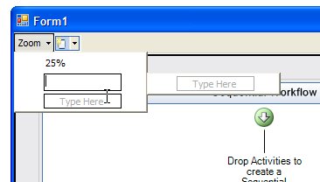

Now that we have created our drop down options we need to set the some parameters and event handlers for each. We will use the Tag to store the actual zoom factor for the each item.
- Click on the first item in the list (25%) and press F4 to view the properties window. Set the properties as follows:
  - Name: mni25PercentZoom
  - Tag: 25
- Click on the events icon at the top of the properties window
- Set the Click event handler to zoomDropDownMenuItem_Click using the drop down options

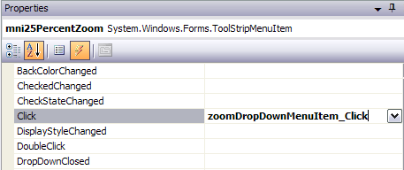

- Click on the second item in the list (100%) and set the properties as follows:
  - Name: mni100PercentZoom
  - Tag: 100
- Click on the events icon at the top of the properties window
- Set the Click event handler to zoomDropDownMenuItem_Click using the drop down options
- Click on the last item in the list (200%) and set the properties as follows:
  - Name: mni200PercentZoom
  - Tag: 200
- Click on the events icon at the top of the properties window
- Set the Click event handler to zoomDropDownMenuItem_Click using the drop down options
- Click Debug | Start Debugging or press F5 to run the project. The application window should appear.
- Click the Zoom drop down button in the Tool Strip and select 25%. Verify that the workflow in the Workflow Designer is displayed quarter its original size.
- Click the Zoom drop down button in the Tool Strip and select 200%. Verify that the workflow in the Workflow Designer is displayed double its original size.
- Close the application window.

Exercise 3 – Adding Activities to the Workflow Designer in a Windows Forms Application

In this exercise, you will write code to add Activities to a Workflow using a toolbox style control. You will also write code that enables the user to select an activity and change its properties, and to delete an activity from the workflow.

Task 1 – Add an Activity ToolBox to the Workflow Designer

- Start with the solution as created in Exercise 2.
- In Solution Explorer, right-click WorkflowDesignerControl.cs, and click View Code.
- Insert the following code into the WorkflowDesignerControl class constructor, directly after the InitializeComponent method call, to add a custom Toolbox control to the WorkflowDesignerControl.

(Snippet: Lab10_Ex03_Task01_ToolBox)
Toolbox toolbox = new Toolbox(this);
this.propertyGridSplitter.Panel1.Controls.Add(toolbox);
toolbox.Dock = DockStyle.Fill;
toolbox.BackColor = BackColor;
toolbox.Font = WorkflowTheme.CurrentTheme.AmbientTheme.Font;

- Now we want to include our custom MessageActivity to the Activity ToolBox so we can use it in our Workflow. MessageActivity is a simple activity that has a Message string property. When executed, the message is displayed in a MessageBox.
- Add the following line of text to the ToolBoxItems.txt file found in the WorkflowDesignControl project.

ActivityLibrary.MessageActivity, ActivityLibrary

Note: At runtime the Toolbox control will read the types specified in this file and load them into the Toolbox.

- Save all files by pressing CTRL + SHIFT + S and run the solution by pressing F5
- The Activity ToolBox should appear in the bottom left hand panel and should include a single Activity named MessageActivity.
- Test the application by dragging and dropping a MessageActivity from the Activity ToolBox onto the Workflow Designer.

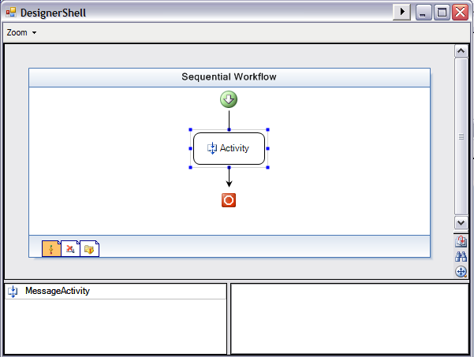

- Exit the DesignerShell program.

Task 2 – Enabling the User to Select an Activity in the Workflow Designer

Now that we can add activities to the workflow, we need to allow the user to select activities and edit their properties.

- In Solution Explorer, right-click WorkflowDesignerControl.cs, and click View Code.
- Locate the LoadWorkflow(string xoml) method in the WorkflowDesignerControl class and add the following code highlighted in grey just after line this.workflowView.Focus().

(Snippet: Lab10_Ex03_Task02_SelectionChanged)

private void LoadWorkflow(string xoml)
{
SuspendLayout();

DesignSurface designSurface = new DesignSurface();
WorkflowLoader loader = new WorkflowLoader();
loader.Xoml = xoml;
designSurface.BeginLoad(loader);

IDesignerHost designerHost = designSurface.GetService(typeof(IDesignerHost)) as IDesignerHost;
if (designerHost != null && designerHost.RootComponent != null)
{
IRootDesigner rootDesigner = designerHost.GetDesigner(designerHost.RootComponent) as IRootDesigner;
if (rootDesigner != null)
{
UnloadWorkflow();

this.designSurface = designSurface;
this.loader = loader;
this.workflowView = rootDesigner.GetView(ViewTechnology.Default) as WorkflowView;
this.workflowViewSplitter.Panel1.Controls.Add(this.workflowView);
this.workflowView.Dock = DockStyle.Fill;
this.workflowView.TabIndex = 1;
this.workflowView.TabStop = true;
this.workflowView.HScrollBar.TabStop = false;
this.workflowView.VScrollBar.TabStop = false;
this.workflowView.Focus();

ISelectionService selectionService = GetService(typeof(ISelectionService)) as ISelectionService;

if (selectionService != null)
{
selectionService.SelectionChanged += new EventHandler(OnSelectionChanged);
}
}
}

ResumeLayout(true);
}

- And add the following event handler to the WorkflowDesignerControl class just below the ProcessZoom method we added earlier.

(Snippet: Lab10_Ex03_Task02_OnSelectionChanged)
private void OnSelectionChanged(object sender, EventArgs e)
{
ISelectionService selectionService = GetService(typeof(ISelectionService)) as ISelectionService;

if (selectionService != null)
{
this.propertyGrid.SelectedObjects = new ArrayList(selectionService.GetSelectedComponents()).ToArray();
}
}

- Now when the selected activity changes within the WorkflowDesignerControl, the PropertyGrid control located in the bottom right hand corner will load the properties for the selected activity.
- Press F5 to run the application and test the activity selection.
- Your form should now look similar to this:

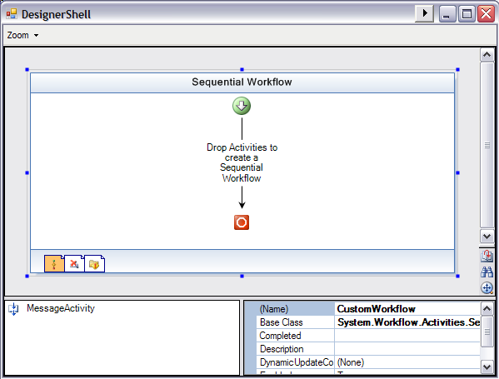

- Drag and drop two MessageActivities onto the Workflow.
- Select the first MessageActivity and set it’s properties as follows
  - Name: activity01
  - Description: “This is message activity 01”
- Select the second MessageActivity and set it’s properties as follows
  - Name: activity02
  - Description: “This is message activity 02”
- You will notice that as you modify each activities properties the changes are reflected in the designer.
- Close the application.

Task 3 – Enabling the User to Delete an Activity in the Workflow Designer

- In Solution Explorer, right-click WorkflowDesignerControl.cs, and click View Code.
- Insert the following method into the WorkflowDesignerControl class just below the OnSelectionChanged method to add functionality to delete the selected Activity.

(Snippet: Lab10_Ex03_Task03_DeleteSelected)
public void DeleteSelected()
{
ISelectionService selectionService = (ISelectionService) this.GetService(typeof(ISelectionService));

if (selectionService != null)
{
if (selectionService.PrimarySelection is Activity)
{
Activity activity = (Activity)selectionService.PrimarySelection;

if (activity.Name != this.WorkflowName)
{
activity.Parent.Activities.Remove(activity);
this.workflowView.Update();
}
}
}
}

- Press F6 to build the solution.
- In the Solution Explorer right-click DesignerShell.cs and select View Designer.
- Select the toolStrip control and using the Smart Task tool add a Seperator.

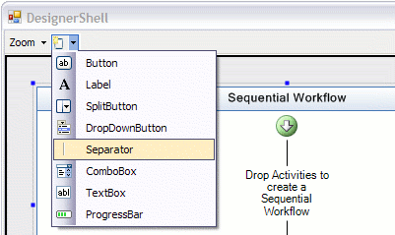

- Using the Smart Task tool again add a new Button.

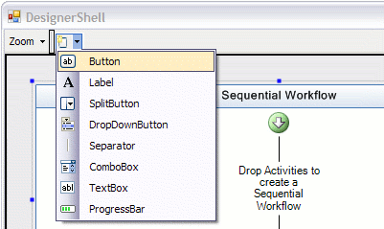

- Set the buttons properties as follows:
  - Name: btnDelete
  - DisplayStyle: Text
  - Text: “Remove Activity”
- Now return to the designer and double click btnDelete to create the default Click handler.
- Within the newly created event handler add the following line of code:

private void btnDelete_Click(object sender, EventArgs e)
{
this.workflowDesignerControl.DeleteSelected();
}

- Press F5 to build and run the application.
- Drag and drop two or more MessageActivities onto the workflow.
- Select one of the MessageActivities within the workflow and click the Remove Activity button.
- Verify that the activity is removed from the workflow.
- Close the application.

Exercise 4 – Programmatically Opening, Saving, Compiling and Running Workflows in the Workflow Designer

Task 1 – Design the User Interface

- Start with the solution as created in Exercise 3.
- In Solution Explorer, double-click DesignerShell.cs to show the designer view.
- Select the toolStrip control and use the Smart Task tool to add a Seperator.
- Use the Smart Task tool again and add a new Button.
- Set the Button properties as follows:
  - Name: btnOpen
  - DisplayStyle: Text
  - Text: Open
- Your form should now look similar to the following:

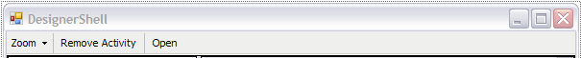

- Using the Smart Task tool, add three more Buttons to the toolStrip and set their properties as follows:
  - Button01
    - Name: btnSave
    - DisplayStyle: Text
    - Text: “Save”
  - Button02
    - Name: btnCompile
    - DisplayStyle: Text
    - Text: ‘Compile”
  - Button03
    - Name: btnRun
    - DisplayStyle: Text
    - Text: “Run”
- Your form should look similar to the following:

Task 2 – Add Common File Operations

- In Solution Explorer, right-click WorkflowDesignerControl and select View Code.
- Add the following method to the WorkflowDesignerControl class just after the DeleteSelected method to add functionality to open existing workflows from file.

(Snippet: Lab10_Ex04_Task02_LoadExistingWorkflow)
public void LoadExistingWorkflow()
{
OpenFileDialog openFileDialog = new OpenFileDialog();
openFileDialog.Filter = "xoml files (*.xoml)|*.xoml|All files (*.*)|*.*";
openFileDialog.FilterIndex = 1;
openFileDialog.RestoreDirectory = true;

if (openFileDialog.ShowDialog() == DialogResult.OK)
{
using (XmlReader xmlReader = XmlReader.Create(openFileDialog.FileName))
{
WorkflowMarkupSerializer serializer = new WorkflowMarkupSerializer();
this.workflow = (SequentialWorkflowActivity)serializer.Deserialize(xmlReader);
this.LoadWorkflow();

this.XomlFile = openFileDialog.FileName;
this.Text = "Designer Hosting Sample -- [" + openFileDialog.FileName + "]";
}
}
}

- Add the following methods to the WorkflowDesignerControl class just after the LoadExistingWorkflow method to add functionality to save workflows to file.

(Snippet: Lab10_Ex04_Task02_Save)
private void SaveFile()
{
if (this.XomlFile.Length != 0)
{
this.SaveExistingWorkflow(this.XomlFile);
}
else
{
SaveFileDialog saveFileDialog = new SaveFileDialog();
saveFileDialog.Filter = "xoml files (*.xoml)|*.xoml|All files (*.*)|*.*";
saveFileDialog.FilterIndex = 1;
saveFileDialog.RestoreDirectory = true;

if (saveFileDialog.ShowDialog() == DialogResult.OK)
{
this.SaveExistingWorkflow(saveFileDialog.FileName);
this.Text = "Designer Hosting Sample -- [" + saveFileDialog.FileName + "]";
}
}
}

internal void SaveExistingWorkflow(string filePath)
{
if (this.designSurface != null && this.loader != null)
{
this.XomlFile = filePath;
this.loader.PerformFlush();
}
}

public bool Save()
{
return this.Save(true);
}

public bool Save(bool showMessage)
{
Cursor cursor = this.Cursor;
this.Cursor = Cursors.WaitCursor;

bool saveOK = true;

try
{
// Save the workflow first, and capture the filePath of the workflow
this.SaveFile();

XmlDocument doc = new XmlDocument();
doc.Load(this.XomlFile);
XmlAttribute attrib = doc.CreateAttribute("x", "Class", "http://schemas.microsoft.com/winfx/2006/xaml");
attrib.Value = string.Format("{0}.{1}", this.GetType().Namespace, this.WorkflowName);
doc.DocumentElement.Attributes.Append(attrib);
doc.Save(this.XomlFile);

if (showMessage)
{
MessageBox.Show(this, "Workflow generated successfully. Generated xoml file:\n" + Path.Combine(Path.GetDirectoryName(this.GetType().Assembly.Location), this.XomlFile), this.Text, MessageBoxButtons.OK, MessageBoxIcon.Information);
}
}
catch (Exception ex)
{
MessageBox.Show(ex.ToString());
saveOK = false;
}
finally
{
this.Cursor = cursor;
}

return saveOK;
}

- Add the following methods to the WorkflowDesignerControl class just after the Save(bool showMessage) method to add functionality to compile your workflows.

(Snippet: Lab10_Ex04_Task02_Compile)
public bool Compile()
{
return this.Compile(true);
}

public bool Compile(bool showMessage)
{
if (!this.Save(false))
{
return false;
}

if (!File.Exists(this.XomlFile))
{
MessageBox.Show(this, "Cannot locate xoml file: " + Path.Combine(Path.GetDirectoryName(this.GetType().Assembly.Location), XomlFile), this.Text, MessageBoxButtons.OK, MessageBoxIcon.Error);
return false;
}

bool compileOK = true;

Cursor cursor = this.Cursor;
this.Cursor = Cursors.WaitCursor;

try
{
// Compile the workflow
String[] assemblyNames = { AdditionalAssembies };
WorkflowCompiler compiler = new WorkflowCompiler();
WorkflowCompilerParameters parameters = new WorkflowCompilerParameters(assemblyNames);
parameters.LibraryPaths.Add(Path.GetDirectoryName(typeof(ActivityLibrary.MessageActivity).Assembly.Location));
parameters.GenerateInMemory = true;
WorkflowCompilerResults compilerResults = compiler.Compile(parameters, this.XomlFile);

inMemoryAssembly = compilerResults.CompiledAssembly;

StringBuilder errors = new StringBuilder();

foreach (CompilerError compilerError in compilerResults.Errors)
{
errors.Append(compilerError.ToString() + '\n');
}

if (errors.Length != 0)
{
MessageBox.Show(this, errors.ToString(), this.Text, MessageBoxButtons.OK, MessageBoxIcon.Error);
compileOK = false;
}
else if (showMessage)
{
MessageBox.Show(this, "Workflow compiled successfully. Compiled assembly:\n" + compilerResults.CompiledAssembly.GetName(), this.Text, MessageBoxButtons.OK, MessageBoxIcon.Information);
}
}
finally
{
this.Cursor = cursor;
}

return compileOK;
}

Notice the line above which reads parameters.GenerateInMemory = true; This means that we are generating the assembly in memory and not writing to file. If you want to generate a .dll for your workflow you could try the following
parameters.GenerateInMemory = false;
parameters.OutputAssembly = string.Format("{0}.dll", this.WorkflowName);

- Add the following methods to the WorkflowDesignerControl class just after the Compile(bool showMessage) method to add functionality to run your workflow.

(Snippet: Lab10_Ex04_Task02_Run)
public bool Run()
{
if (inMemoryAssembly == null)
{
if (!this.Compile(false))
{
return false;
}
}

// Start the runtime engine
if (this.workflowRuntime == null)
{
this.workflowRuntime = new WorkflowRuntime();
this.workflowRuntime.StartRuntime();
}

this.workflowRuntime.WorkflowCompleted += new EventHandler<WorkflowCompletedEventArgs>(workflowRuntime_WorkflowCompleted);
string typeName = string.Format("{0}.{1}", this.GetType().Namespace, this.WorkflowName);
this.workflowRuntime.CreateWorkflow(AppDomain.CurrentDomain.CreateInstanceAndUnwrap(inMemoryAssembly.FullName, typeName).GetType()).Start();

return true;
}

void workflowRuntime_WorkflowCompleted(object sender, WorkflowCompletedEventArgs e)
{
MessageBox.Show("Workflow complete");
}

- In the Solution Explorer right-click the DesignerShell.cs file and selct View Code.
- Insert the following event handlers into the DesignerShell class just after the btnDelete_Click event handler

(Snippet: Lab10_Ex04_Task02_EventHandlers)
private void btnSave_Click(object sender, EventArgs e)
{
this.workflowDesignerControl.Save();
}

private void btnCompile_Click(object sender, EventArgs e)
{
this.workflowDesignerControl.Compile();
}

private void btnRun_Click(object sender, EventArgs e)
{
this.workflowDesignerControl.Run();
}

private void btnOpen_Click(object sender, EventArgs e)
{
this.workflowDesignerControl.LoadExistingWorkflow();
}

- Return to the form designer for the DesignerShell form.
- Select btnOpen and press F4 to open the properties window,
- Click on the events icon at the top of the properties window
- Set the Click event handler to btnOpen_Click using the drop down options

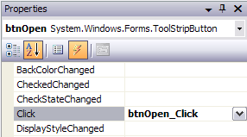

- With the property window still open, select btnSave on the form designer.
- Set the Click event handler to btnSave_Click using the drop down options
- Using the same process set the click handler for btnCompile to btnCompile_Click and the click handler for btnRun to btnRun_Click.
- Press F5 to run the application.
- To verify our application is running correctly drag and drop two MessageActivities onto the Workflow.
- Select the first MessageActivity and set its message property to “Hello”.

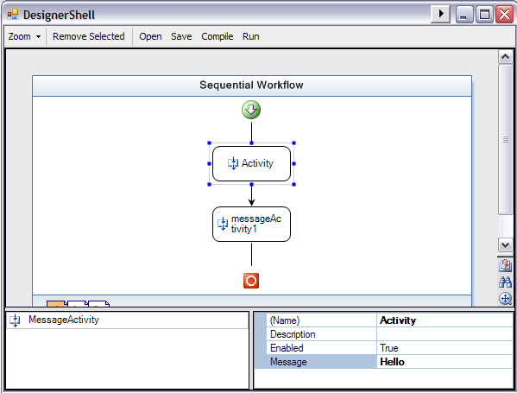

- Select the second MessageActivity and set its message property to “World”.

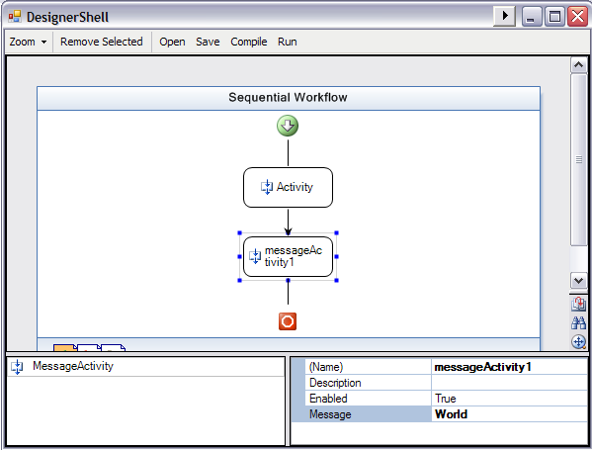

- Click the Run button, this will save, compile and run the workflow. As we have not yet saved our workflow you will be prompted to save before the application can compile and run your workflow. In the Save File Dialog save your workflow to c:\Windows Workflow Foundation\Labs\Lab10\DesignerHostingApplication\CustomWorkflow.xoml and click Save. Once you have saved the application will continue to compile and run your workflow.
- Verify that you see three message boxes appear, the first saying “Hello”, the second saying “World” and the third informing you that the Workflow has completed successfully.

Task 3 – Bind Activities in the Workflow Designer

For this task we are going to bind to activities within our workflow. The first activity will display a question for the user and allow them to enter an answer, the second activity will be bound to the first activity and will display the users answer in a MessageBox.

We will add a second custom activity to the Activity Toolbox called PromptActivity. PromptActivity is a simple activity that provides the functionality to ask the user our question and receive the answer.

- To add the PromptActivity to our Activity Toolbox add the following gray highlighted line of text to the ToolboxItems.txt file found in the WorkflowDesignerControl project.

ActivityLibrary.MessageActivity, ActivityLibrary
ActivityLibrary.PromptActivity, ActivityLibrary

- Now, we want to be able to bind the Message property of a MessageActivity to a PromptActivity’s Answer property, to do this we must modify the MessageActivity slightly. Right-click on MessageActivity.cs in the ActivityLibrary project and select View Code.
- Delete the private message field and public Message property from the MessageActivity class

private string message;

public string Message
{
get { return message; }
set { message = value; }
}

- And insert the following lines of code in it’s place

(Snippet: Lab10_Ex04_Task03_MessageProperty)
public static DependencyProperty MessageProperty = System.Workflow.ComponentModel.DependencyProperty.Register("Message", typeof(string), typeof(MessageActivity));

[Description("The Message to display in the MessageBox")]
[Browsable(true)]
[DesignerSerializationVisibility(DesignerSerializationVisibility.Visible)]
public string Message
{
get
{
return ((string)(base.GetValue(MessageActivity.MessageProperty)));
}
set
{
base.SetValue(MessageActivity.MessageProperty, value);
}
}

- Locate the Execute method in the MessageActivity class and Capitalize ‘m’ in this.message, to reflect the changes we made to the Message property

MessageBox.Show(this.Message);
- Run the application by pressing F5.
- Notice our new PromptActivity appears in the Activity Toolbox.
- Drag and drop a PromptActivity onto the workflow and set it’s properties as follows:
  - Name: MyQuestion
  - Question: “Do you think Workflow is cool?”

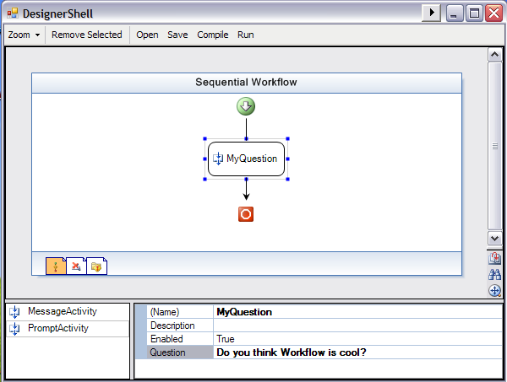

- Drag and drop a MessageActivity onto the workflow after your MyQuestion activity and set it’s properties as follows:
  - Name: MyAnswer
  - Message: Activity=MyQuestion, Path=Answer

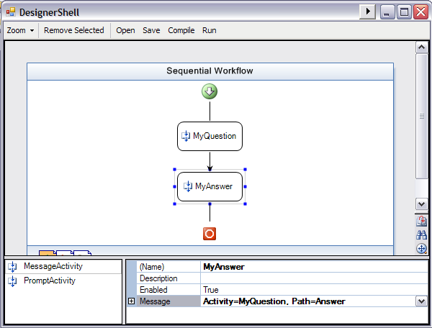

Notice the syntax we have entered for the Message property. What we are saying is: For the Message property get your value from the activity named MyQuestion and the property named Answer
- Click the Run Button
- When prompted, save the workflow by overwriting CustomWorkflow.xoml
- When the question form appears type “Yes!” in the answer box.

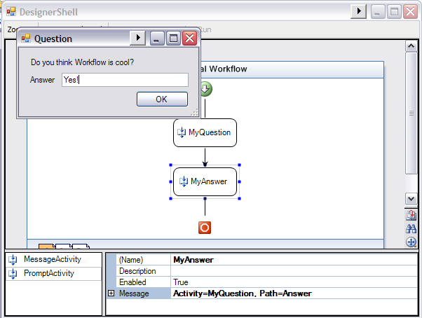

- Click OK
- Another MessageBox should appear with the text “Yes!”.

You have successfully bound the MyAnswer activity to MyQuestion.

- To complete this lab add the following gray highlighted text into the ToolboxItems.txt file to include some other common workflow activities

ActivityLibrary.MessageActivity, ActivityLibrary
ActivityLibrary.PromptActivity, ActivityLibrary
System.Workflow.Activities.DelayActivity
System.Workflow.Activities.HandleExternalEventActivity
System.Workflow.Activities.IfElseActivity
System.Workflow.Activities.CallExternalMethodActivity
System.Workflow.Activities.InvokeWebServiceActivity
System.Workflow.Activities.InvokeWorkflowActivity
System.Workflow.Activities.ListenActivity
System.Workflow.Activities.ParallelActivity
System.Workflow.Activities.ReplicatorActivity
System.Workflow.Activities.SequenceActivity
System.Workflow.Activities.WhileActivity
System.Workflow.Activities.EventHandlingScopeActivity

- Press F5 to run the application
- Verify that the Activity Toolbox now contains our two custom activities and some common built-in Workflow Activities.
- Close the application.

Lab Summary
In this lab you performed the following exercises.
- Display a Workflow in a Windows Forms application
- Interact programmatically with the Workflow Designer in a Windows Forms application
- Programmatically add activities to the Workflow Designer in a Windows Forms application
- Programmatically open, save, compile and run workflows in the Workflow Designer

In this lab, you created a Windows Forms application that has an embedded Workflow Designer. You wrote code to display a sequential workflow, and added support for zooming operations. You also wrote code to enable the user to add, select, and delete Code Activities in the Workflow Designer. Finally, you wrote code to enable the user to open, save, compile and run workflows and demonstrated activity binding

